**Lecture Notes**

Different types of Testing’s and when they are needed?

1. **Regression testing**Regression testing is the process of testing changes to Applications to make sure that the existing application still works with the new changes.  
Automation testing majorly does Regression testingRecommended before every releaseEffective Regression Tests can be done by selecting the following test cases –Test cases which have frequent defectsFunctionalities CriticalIntegration Test Cases

**2. Smoke tests**

Smoke test development and regression test development are related and similar,

The only difference is in depth scope and duration of running the tests

Typically Runs after every build

Add the most critical tests to the smoke test suite

Automate smoke testing in your CD environment

**3. Component Testing**

Component testing is a method where testing of each component in an application is done separately.

Component testing may be done in isolation from rest of the system depending on the development life cycle model chosen for that particular application. Component testing doesn’t test backend.

Difference between Component Test and Unit Test

Component testing: It involves analyzing multiple functions and code modules before they form software. It is a black box testing technique that evaluates the application without considering the code information. Unit testing: Developers perform Unit testing to ensure all the smaller code units function correctly.

**4. What is Integration Testing?**

Integration Testing is defined as a type of testing where software modules are integrated logically and tested as a group.

**5. System/EndtoEnd Testing:**

SYSTEM TESTING is a level of software testing where a complete and integrated software is tested. The purpose of this test is to evaluate the system's compliance with the specified requirements

https://www.browserstack.com/guide/what-is-system-testing

**6. Exploratory Testing :**

Exploratory testing is an unscripted QA testing technique used to discover unknown issues during and after the software development process

Automation testing has few limits and this exploratory testing is essential to deliver product with bug free confidence

**Difference Between Verification and Validation** :

**Verification** :The process of evaluating work-products (not the actual final product) of a development phase to determine whether they meet the specified requirements for that phase..

**Validation** : The process of evaluating software during or at the end of the development process to determine whether it satisfies specified business requirements.

**UAT(user acceptance testing) Testing:** This is typically the last step before the product goes live or before the delivery of the product is accepted. UAT is after the product itself is thoroughly tested. Actual users and product owners do uat testing.

**\*\*\*\*\*\*\*\*\*\*\*\*\*\*\*\*\*\*\*\*\*\*\*\*\*\*\*\*\*\*\*\*\*\*\*\*\*\*\*\*\*\*\*\*\*\*\*\*\*\*\*\*\*\*\*\*\*\*\*\*\*\*\*\*\*\*\*\*\*\*\*\*\*\*\*\*\*\*\*\*\*\*\*\*\*\*\*\*\*\*\*\*\*\*\*\*\*\*\*\*\*\*\*\*\*\*\*\*\*\*\*\*\*\*\*\*\*\*\*\*\*\*\*\*\*\*\*\*\*\*\*\*\*\***

**Load Testing** : Load Testing help us to study the behavior of the application under various loads. The main parameter to focus is response time. This study reveals how many concurrent users that server can handle effectively and quickly.

**Stress Testing** : Stress Testing help us to observe the stability of the application. The main intention is to identify the breaking point of the server

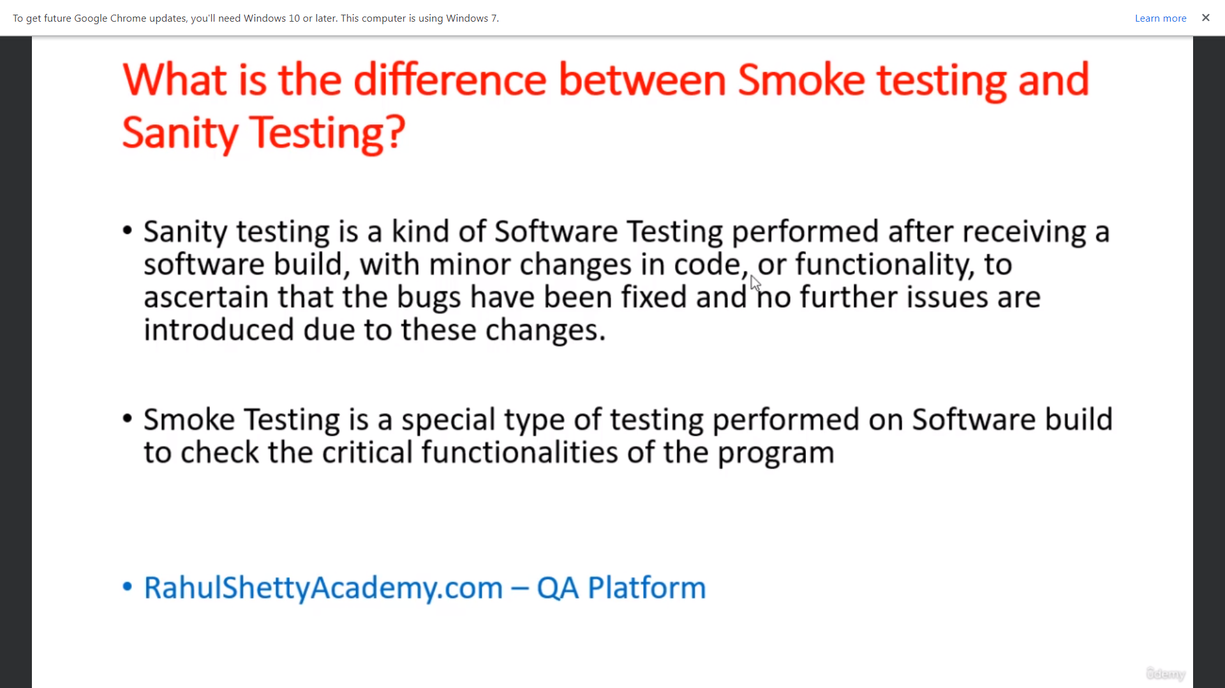

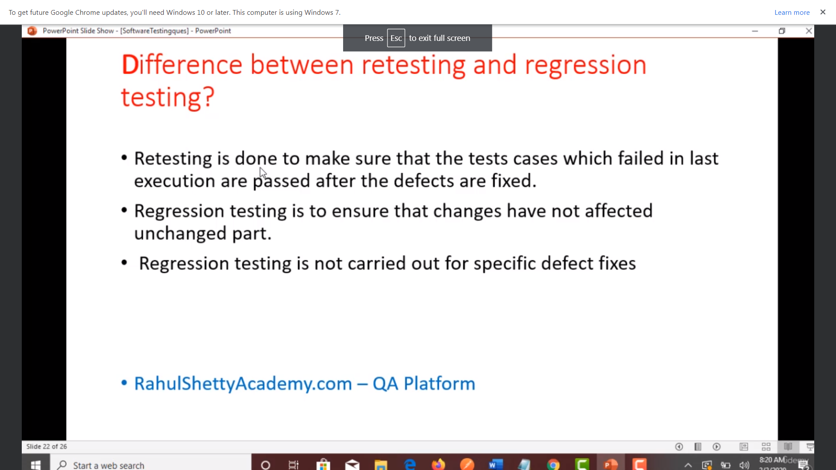

MS MY SQL is DBMS(database management system).

SQL is language to interact with db.

Download MS SQL--🡪Connect to server-🡪Find tables in a database.

Database is collection of tables.

Creating a database with name “qadbt” (lecture 71)

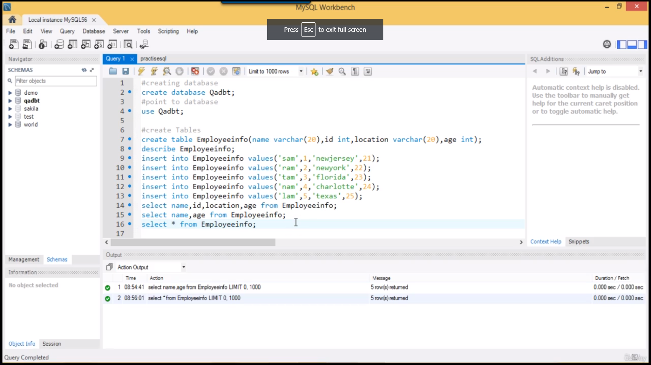

Describe query

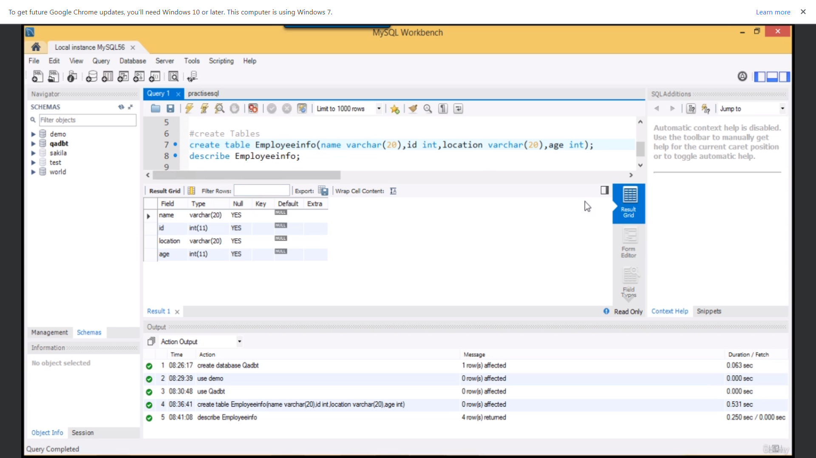

Distinct row only

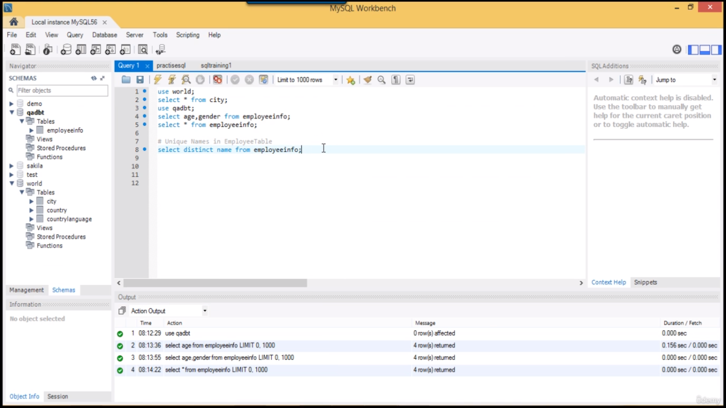

Where, and, or operator

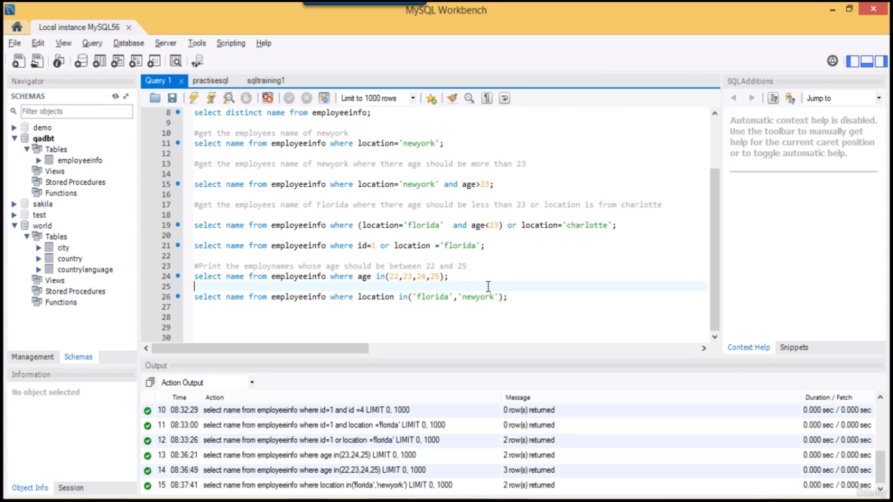

Between operator

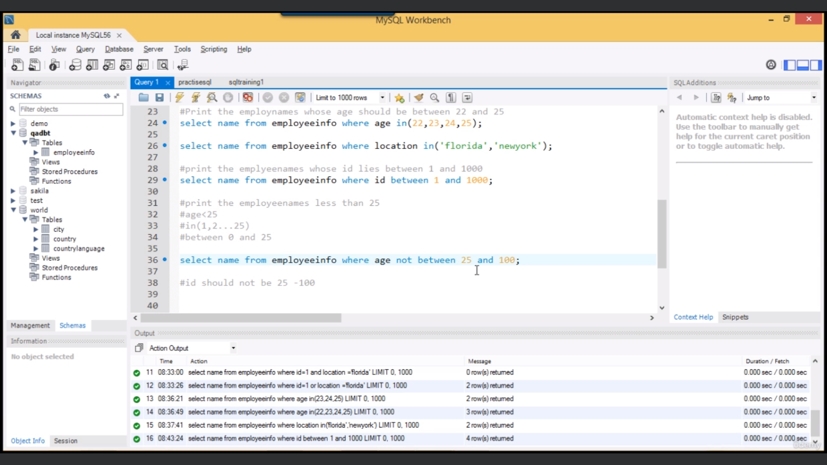

Using like operator with “_” , “%” to retrieve data based on position of a particular letter.

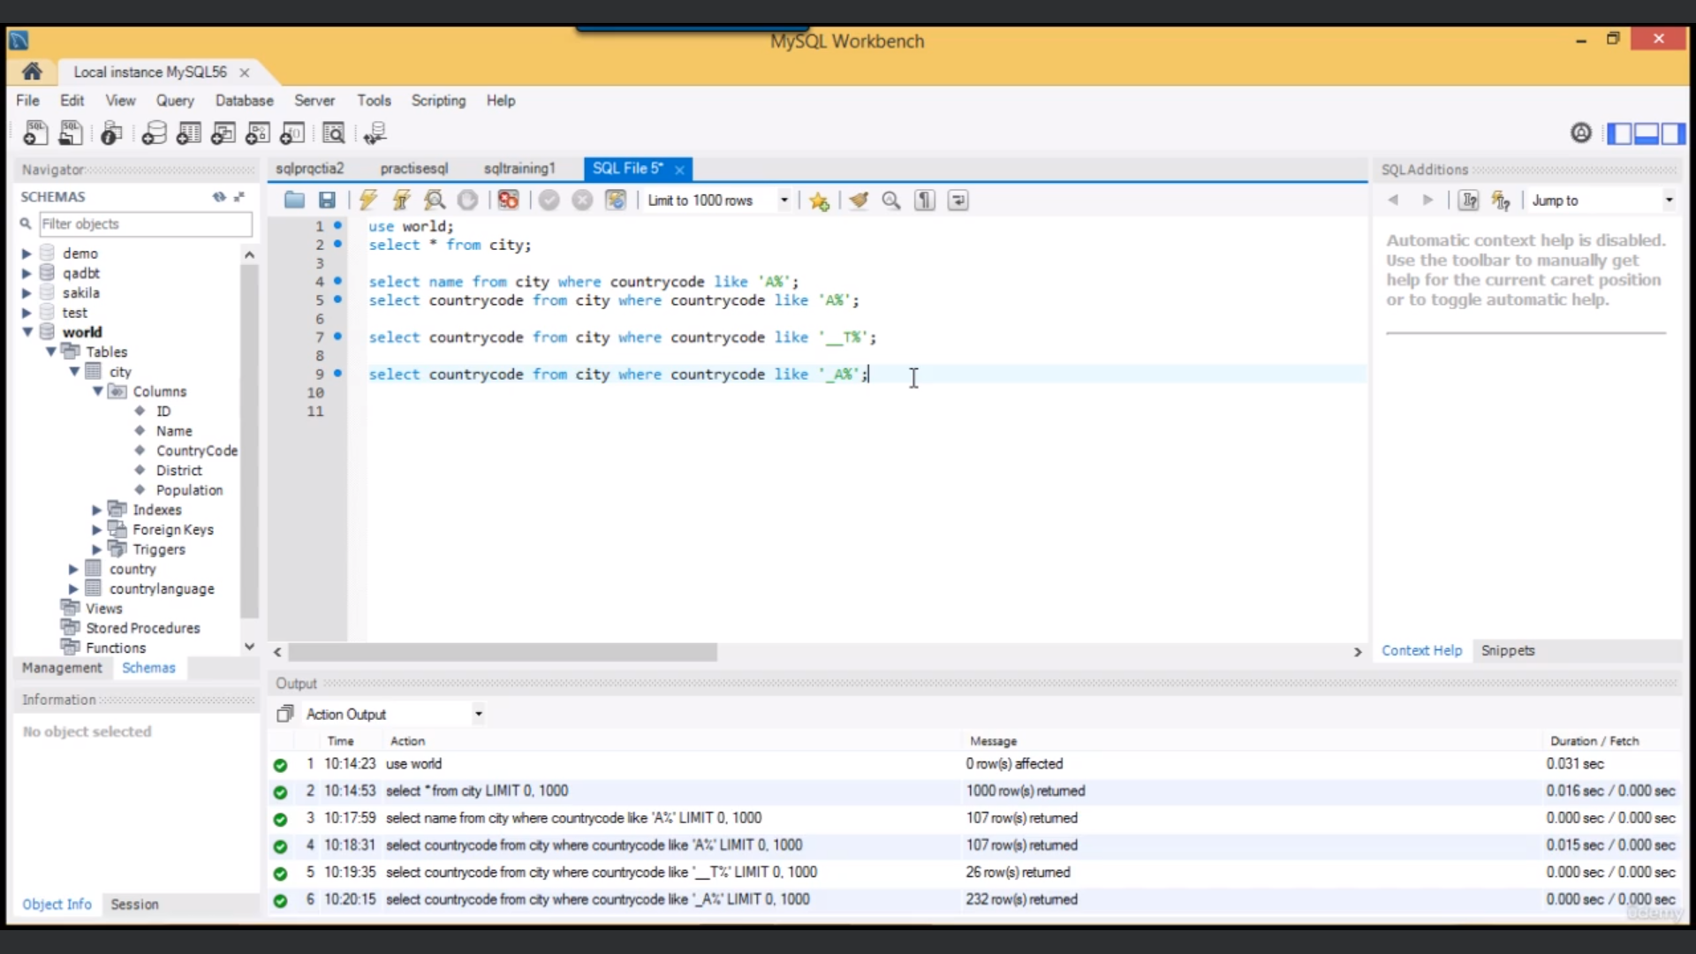

Test scenario: Verify password reset functionality

Test case in column 1

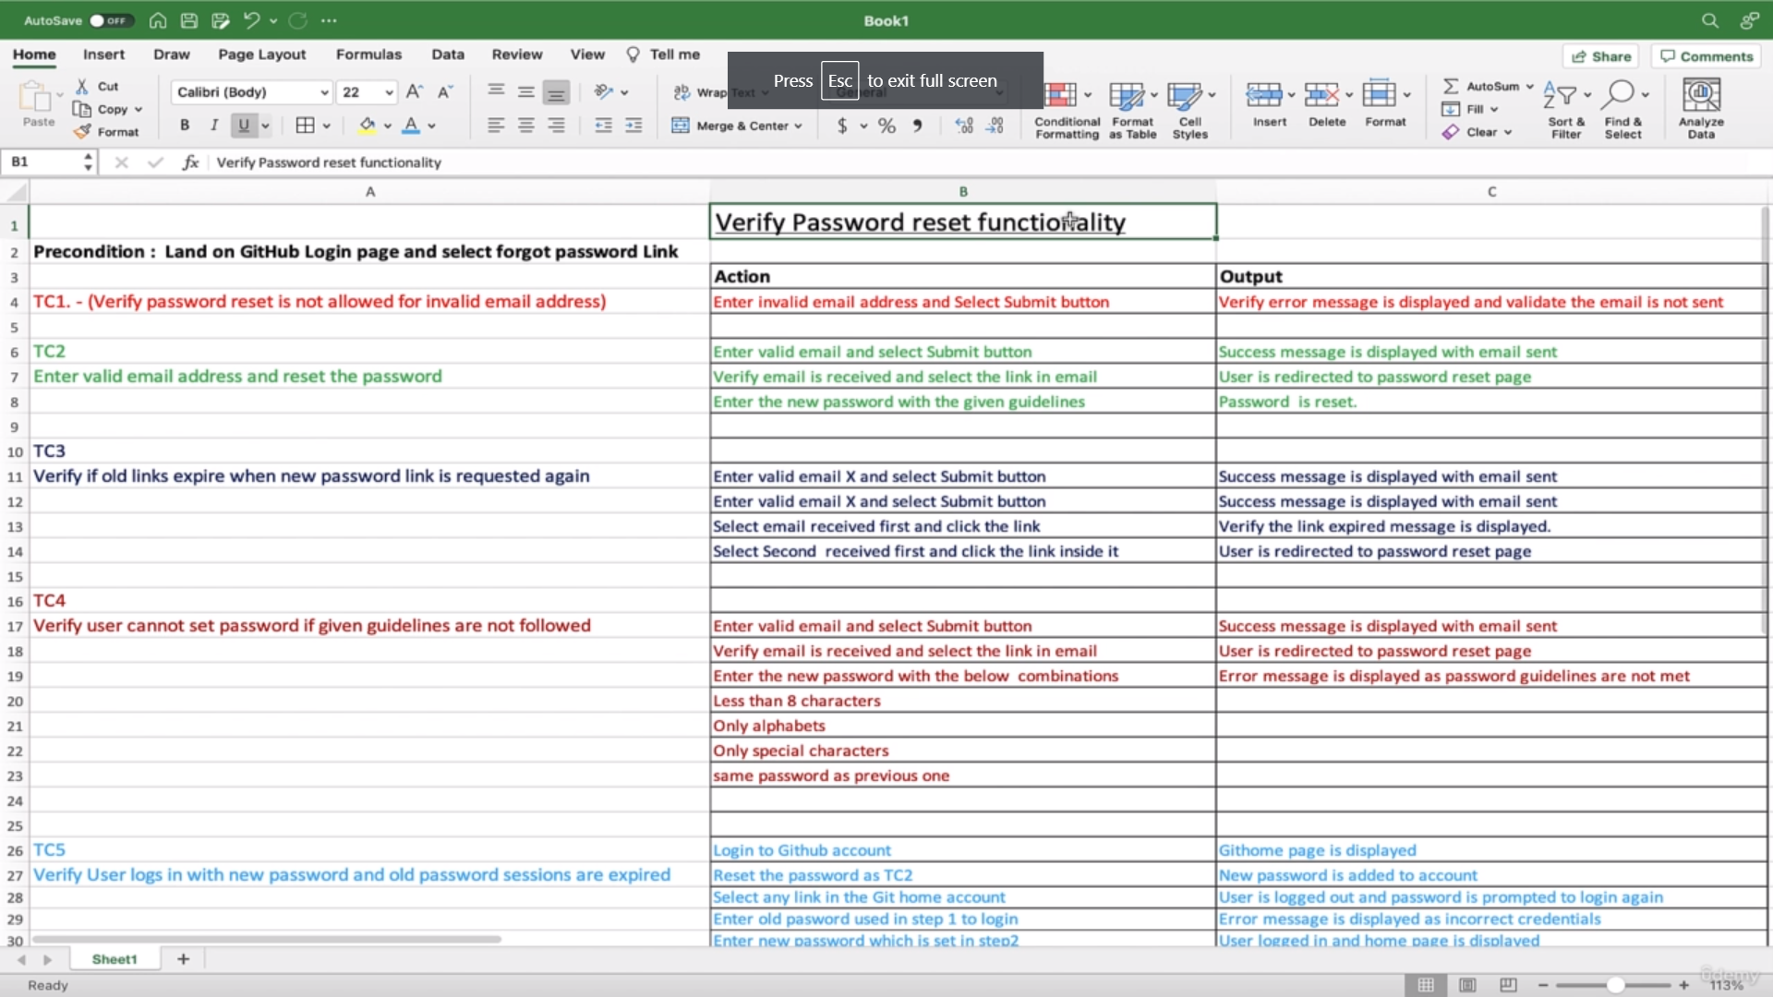

Functional & Non-Functional requirements

<https://www.geeksforgeeks.org/differences-between-functional-and-non-functional-testing/>

Functional Test: Test Behaviour based on input and output.

Non-Functional Test: Test Behaviour based on performance.

**Performance Testing** is a type of [software testing](https://www.geeksforgeeks.org/software-testing-basics/) that ensures [software applications](https://www.geeksforgeeks.org/what-is-application-software/) perform properly under their expected workload. It is a testing technique carried out to determine system performance in terms of sensitivity, reactivity, and stability under a particular workload.

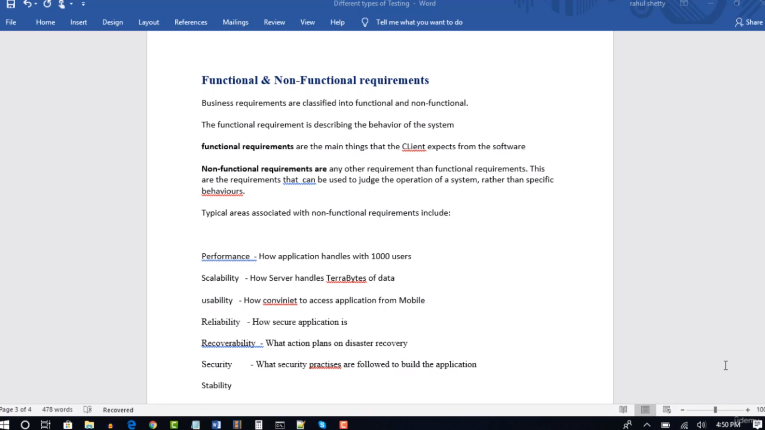

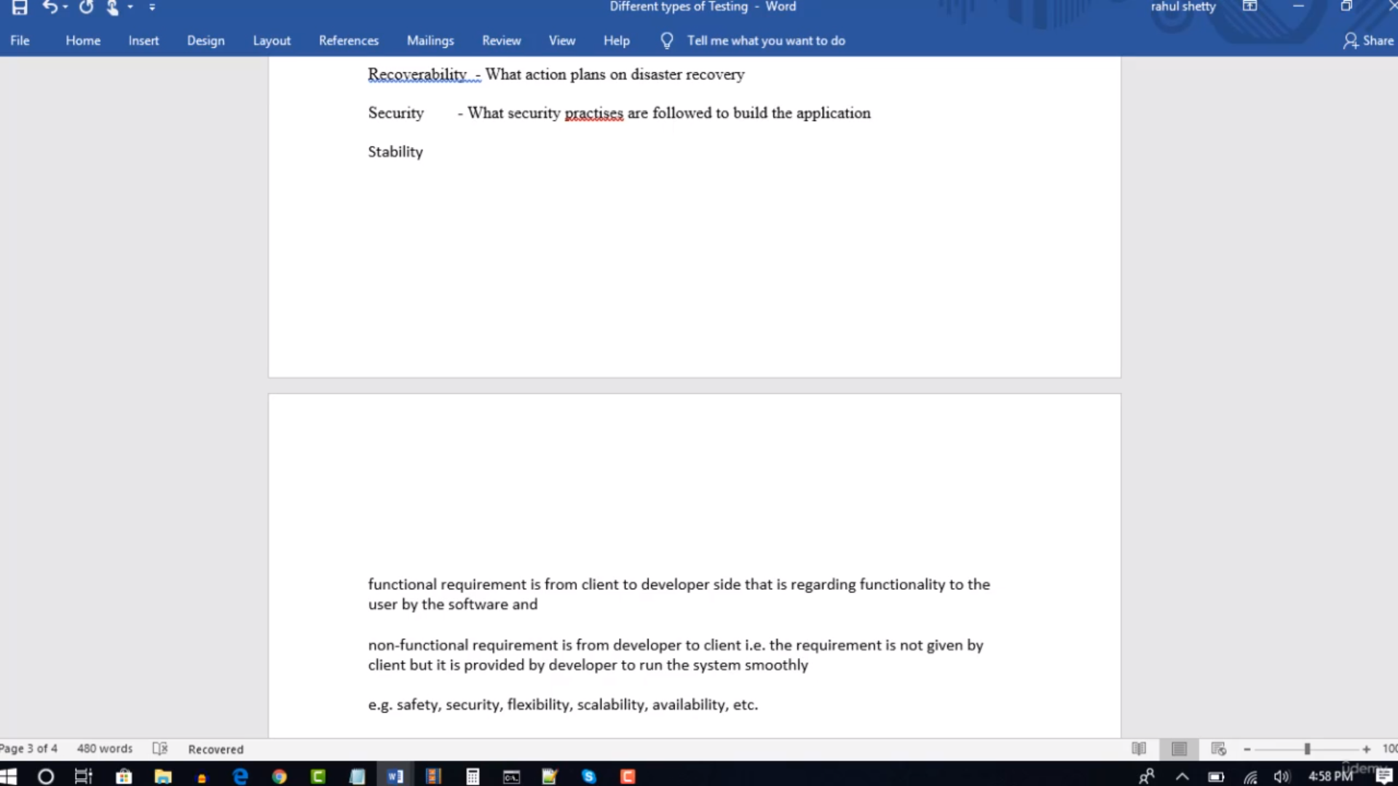

White box & Black box

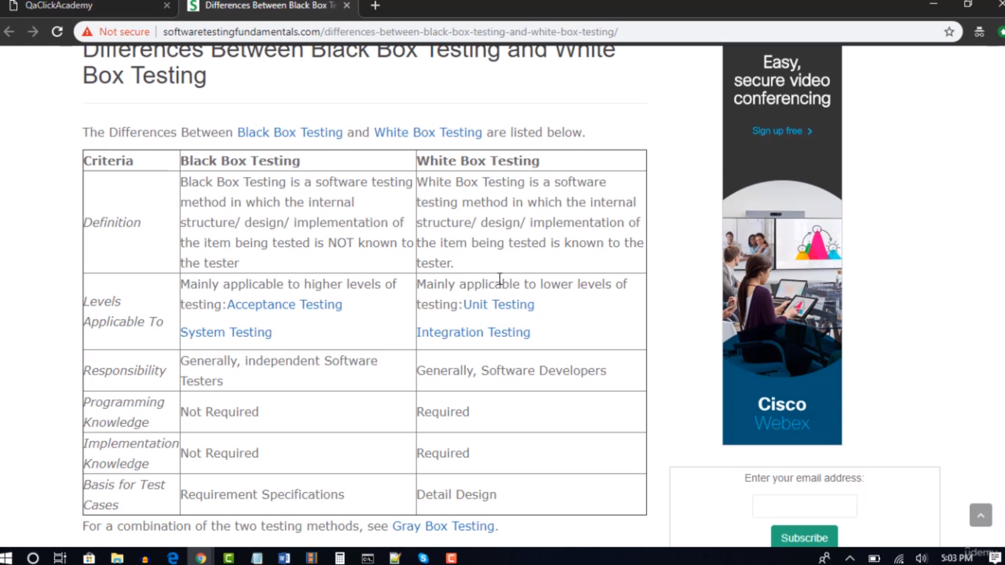

Functional & Non-Functional testing types

<https://testsigma.com/guides/functional-testing/>

https://www.geeksforgeeks.org/software-testing-non-functional-testing/

Api response code:

<https://blog.postman.com/what-are-http-status-codes/>

JSON: Java Script Object Notation

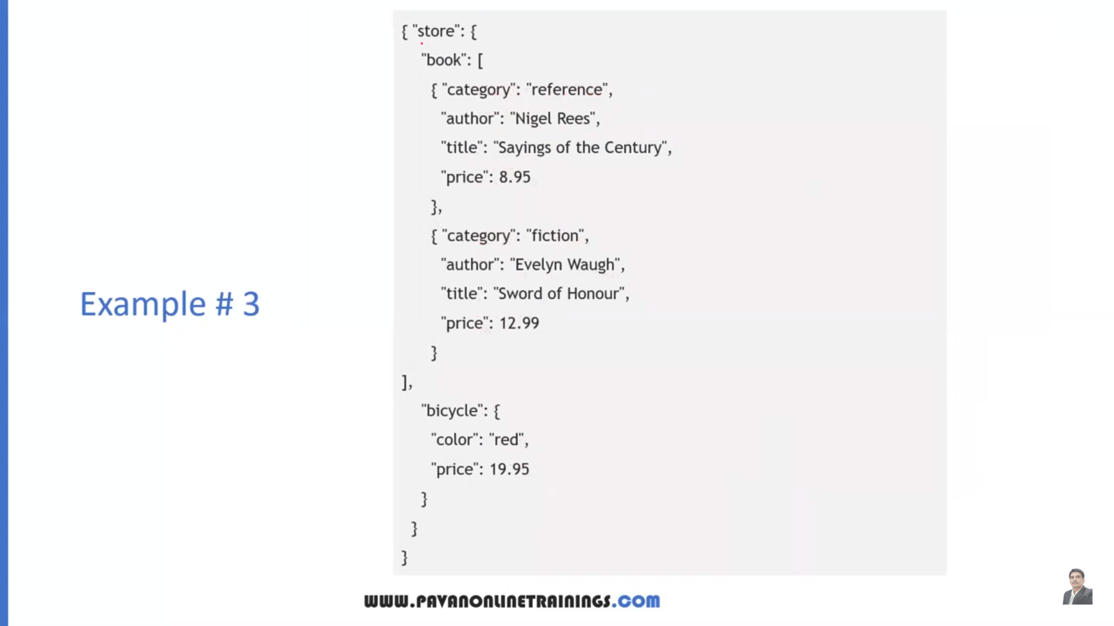

Store object has book array and bicycle object . Book array has two objects. Bicycle object has two key value pairs.

Retrieving data from json

Case1:array

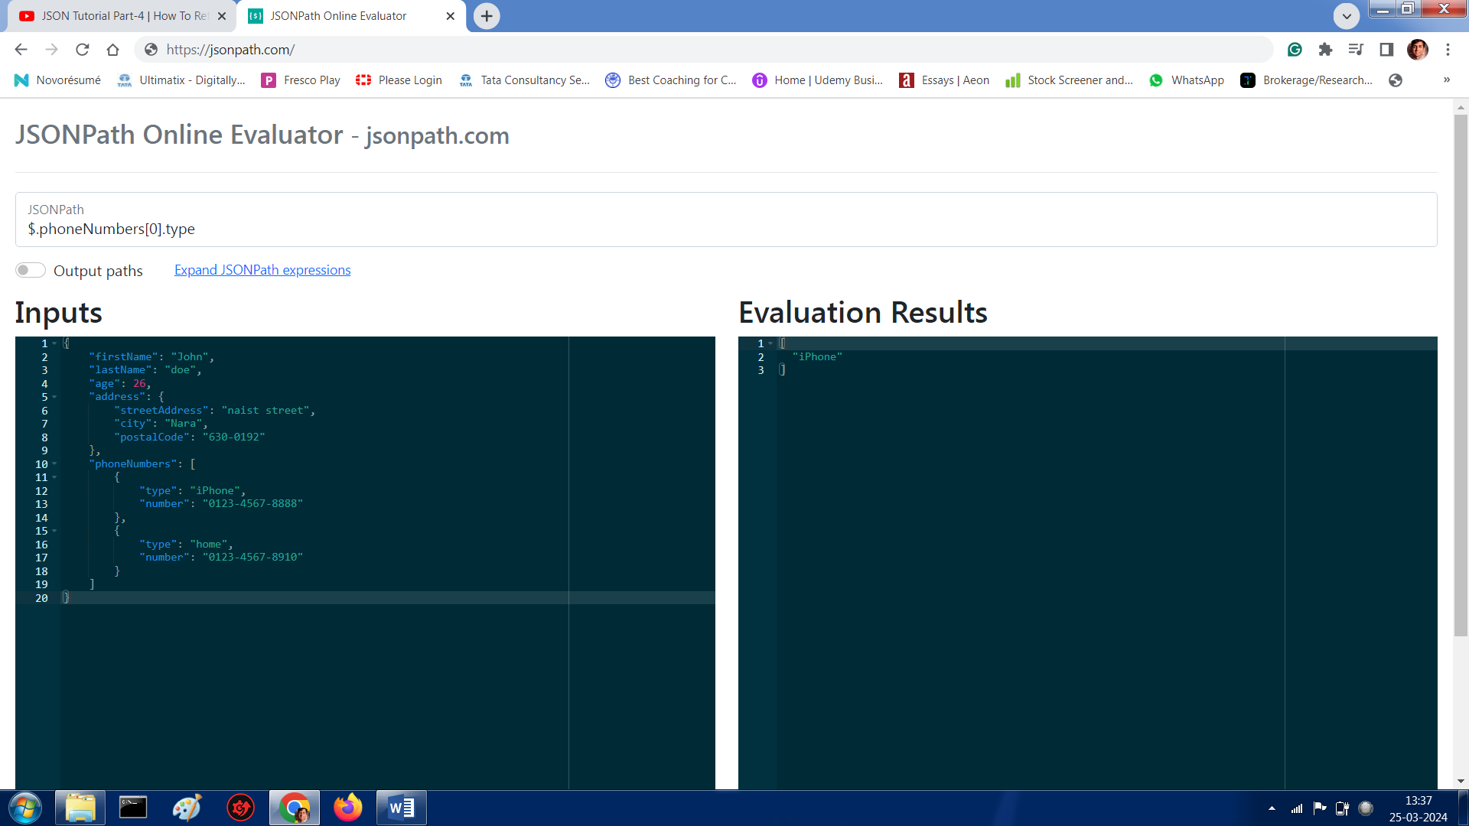

Case 2: Key value pair

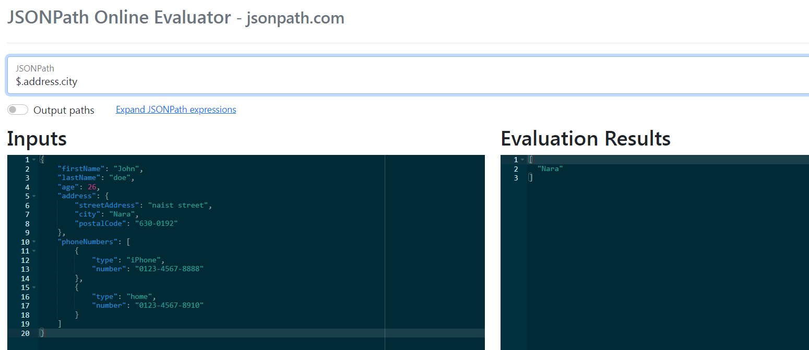

Case3: find from json: $..city

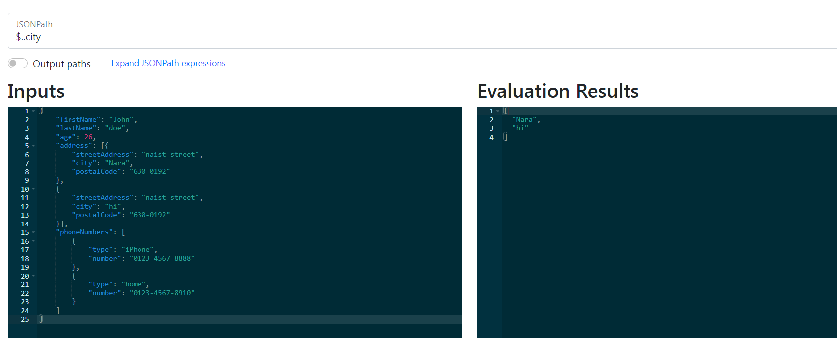

Before bug is created check yourself the issue under “Network” tab

Case1:Incorrect Password, 400 Bad request. (Interraction of UI with db).

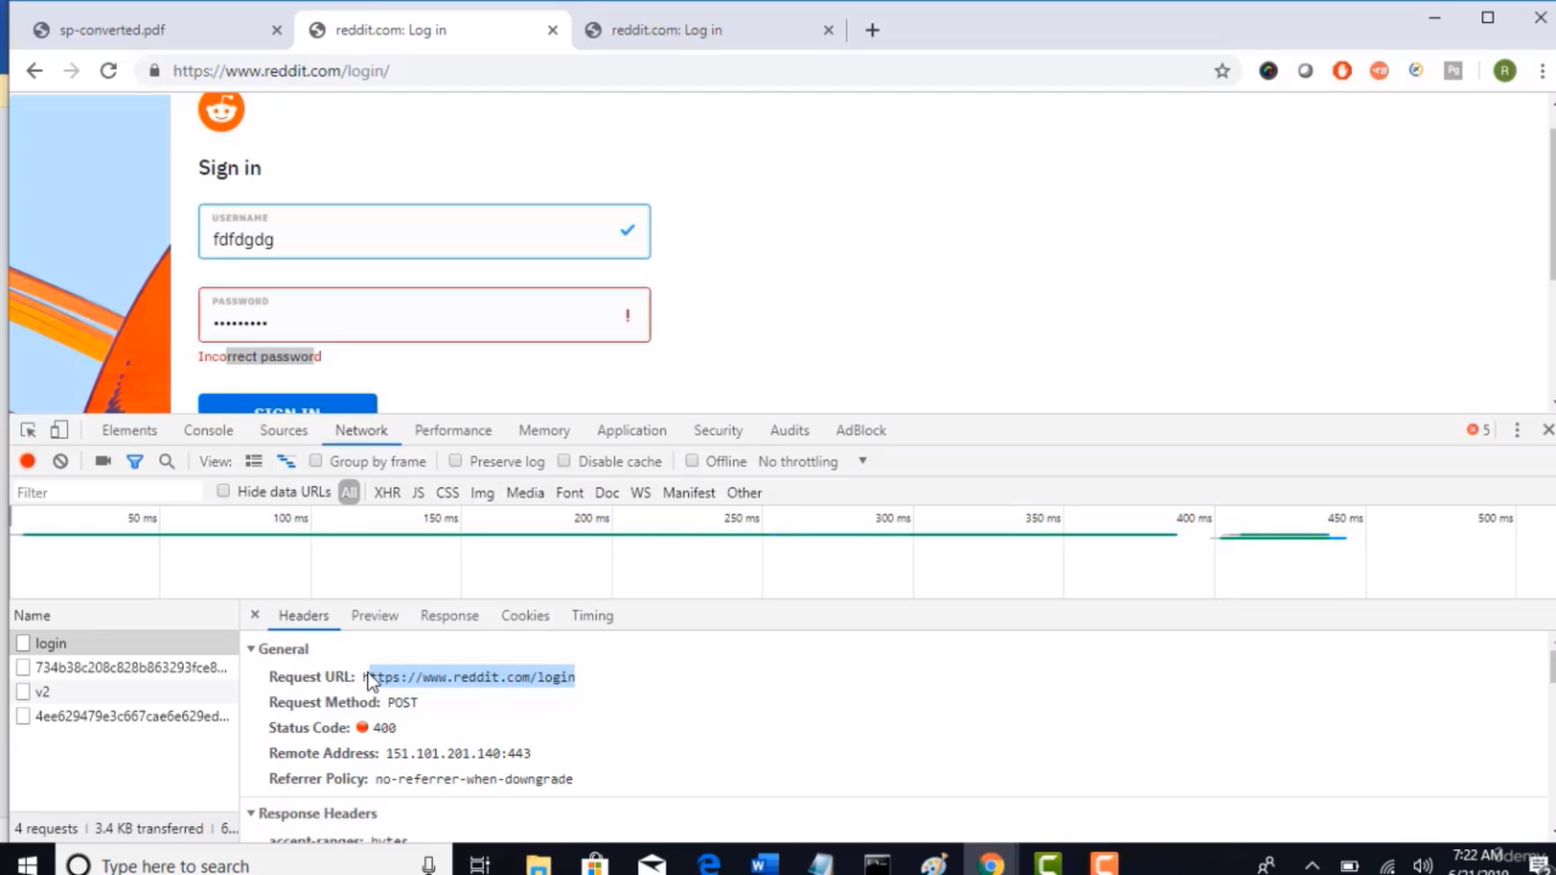

Send details to the developer, share the request being sent:

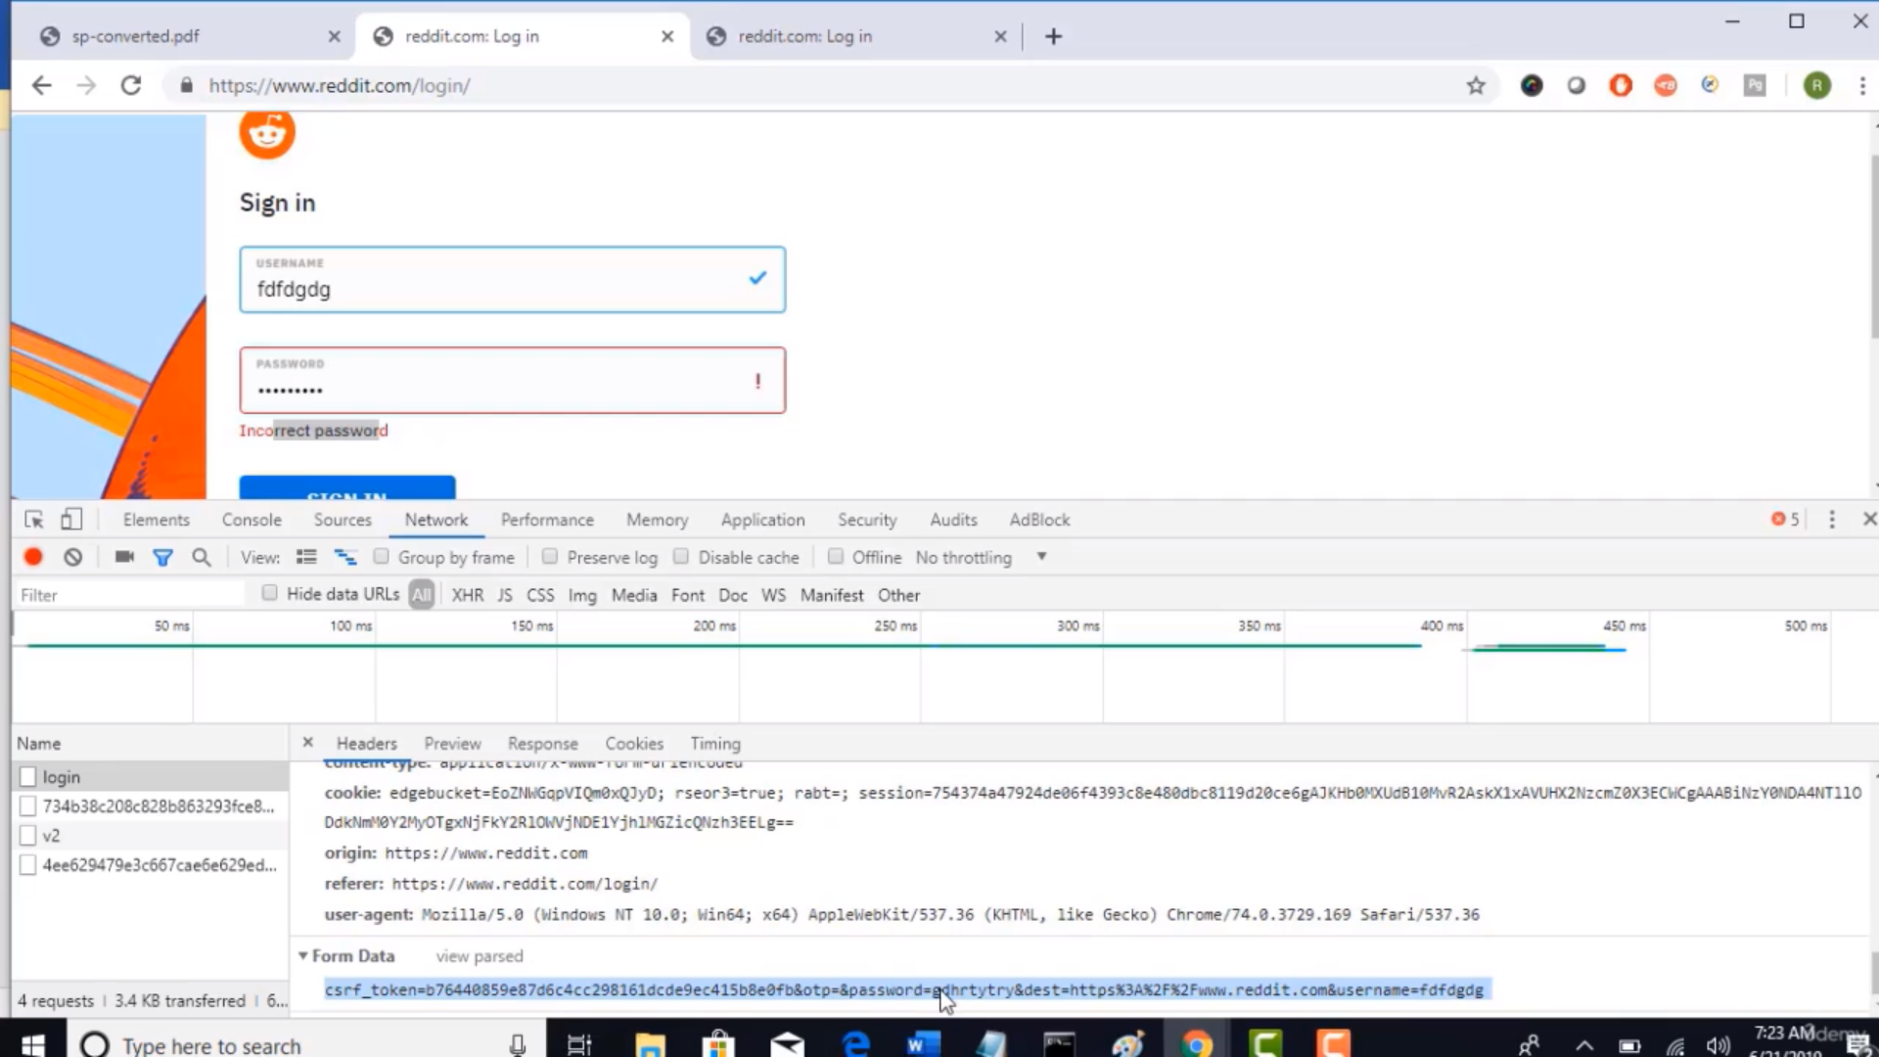

Case 2: Only UI Front end testing under “Console” Tab.

Error at index 6 of code.

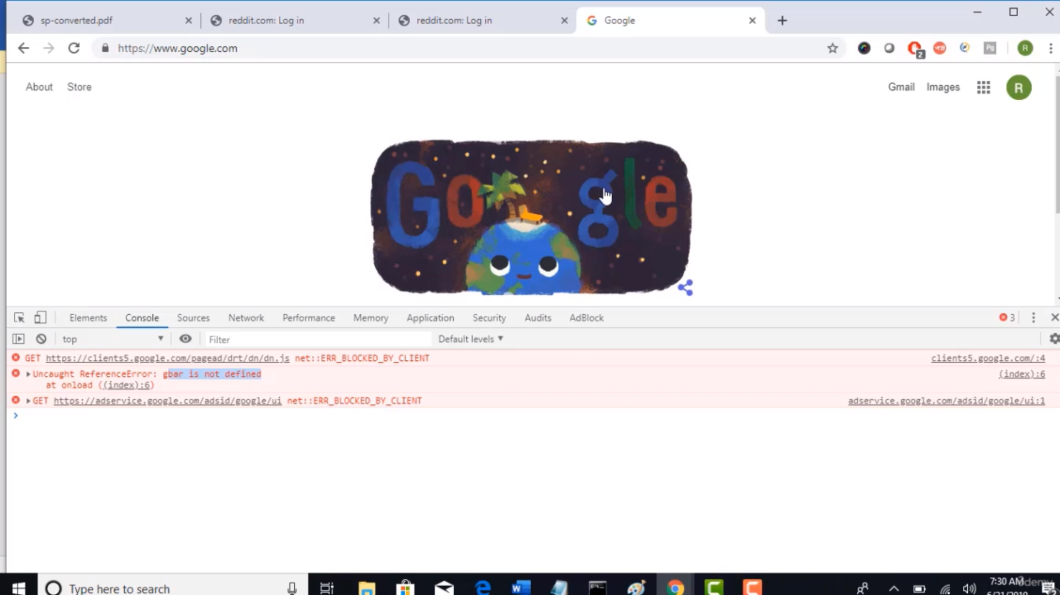

App server logs

Time stamp with steps.

